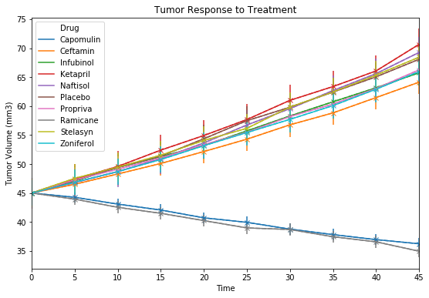

Based on the current data it can be determined the trend only two drugs (Capomulin and Ramicane) are the only two that provide a reduction in tumor volume. The others exhibit an increased growth.

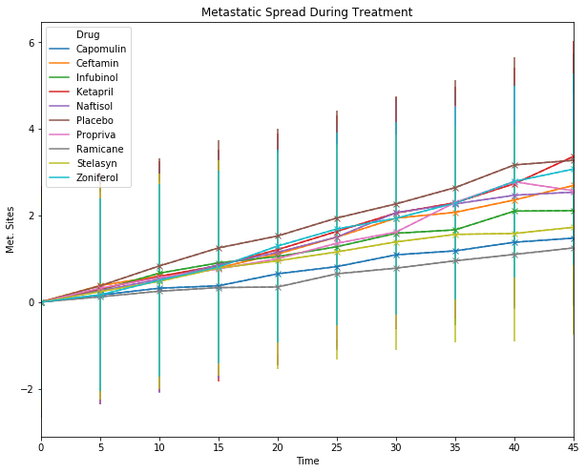

Observable trend: The metastatic spread during treatment, again the Capomulin and Ramicane have the slowest spread given the treatment introduced.

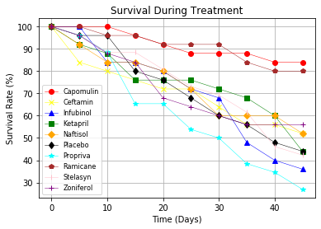

Observable trend: Significant for Campomulin and Ramicane to have highest percent rate with treatment.